

METHODOLOGY AND DESIGN

B.R Vindyani

(ITBIN-2211-0122)

BSc (Hons.) in Information Technology
J.P.I.S Jayasinghe

(ITBIN-2211-0324)

BSc (Hons.) in Information Technology
B.R.G.S Sandaruwan

(ITBIN-2211-0278)

BSc (Hons.) in Information Technology

Faculty of Information Technology

Horizon Campus

November-2025

Table of Contents

Contents

Chapter 3………………………………………………..
  - Introduction
  - Feasibility Study
  - Fact Finding Techniques
  - Requirement Analysis
  - Functional Requirements
  - Non-Functional Requirements
  - Methodology for the System Development

Chapter 4………………………………………………………………
  - Introduction
  - System Design Process
    - Use Case Diagrams
    - Class Diagrams
    - Sequence Diagrams
    - Activity Diagrams
  - Interface Design
    - Design Principles
    - Actual Screens of the System

  - Database Design
    - Entity Relationship Diagrams (ERD)
    - Normalization
    - Relational Schema
  - Hardware Component

CHAPTER 3: ANALYSIS
3.1 Introduction
This chapter presents a comprehensive analysis of the proposed iPermit virtual driving license system, examining its feasibility, requirements, and development methodology. The analysis phase transforms research objectives and literature insights into concrete system specifications that guide design and implementation. The iPermit system aims to revolutionize traffic law enforcement in Sri Lanka by replacing traditional physical driving licenses with an intelligent, AI-powered digital platform integrating facial recognition, automated number plate recognition, violation detection, point-based penalties, and accident visualization.
This chapter examines the existing traffic enforcement system illustrated through use case diagrams, followed by a feasibility study, fact-finding techniques, detailed functional and non-functional requirements, and the selected development methodology.

3.2 Existing System Analysis
3.2.1 Current System Overview
Sri Lanka's traffic enforcement operates through traditional manual processes. Physical plastic card licenses containing photographs and personal details must be carried while driving and presented during roadside checks. Traffic officers conduct manual identity verification by visually comparing drivers with license photographs, checking expiry dates, and examining security features a process averaging 4.2 minutes per driver.
When violations are detected, officers manually write paper citations that are later filed and entered into databases a process prone to errors and delays. Driver records, vehicle registrations, and violation histories exist in fragmented databases across DMT, Police, and Courts with limited real-time integration. Fined drivers must physically visit designated offices to pay penalties.

3.2.2 Top-Level Use Case Diagram - Existing System

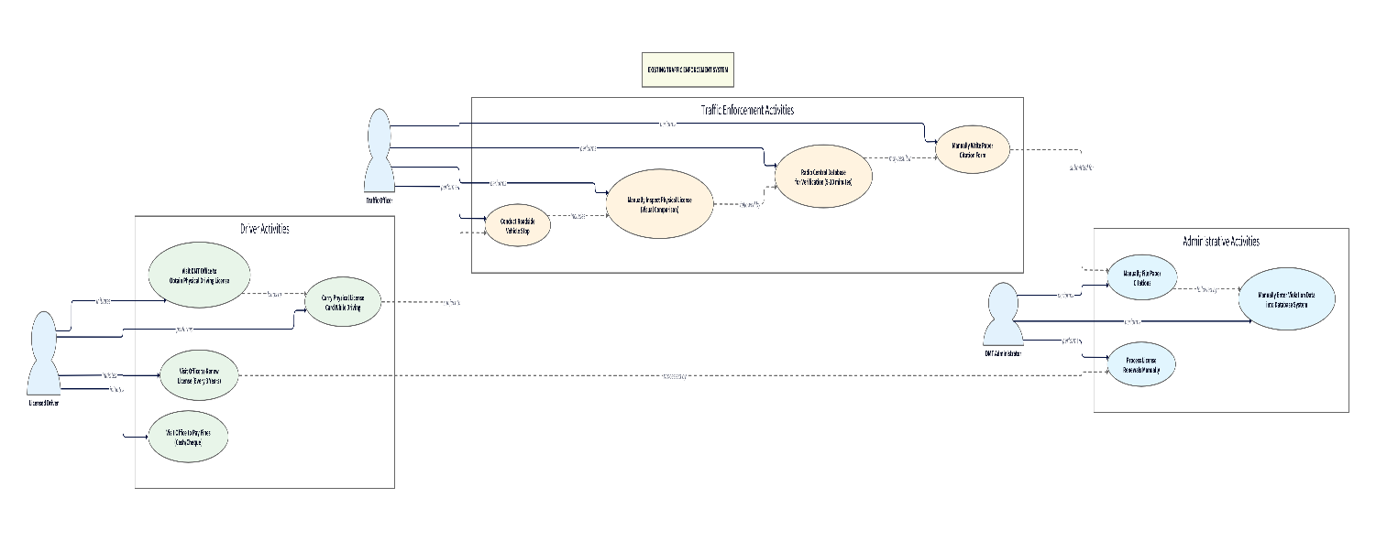

Key Limitations: Physical licenses easily forged (4-6 weekly encounters), manual verification time-consuming (4.2 minutes average), radio database queries delayed (5-10 minutes), paper citations prone to errors and loss, fragmented databases preventing comprehensive history access, no automated violation detection, limited enforcement coverage, drivers lack visibility into violation records, potential for corruption in manual unmonitored processes.

3.3 Proposed System - Top-Level Use Case Diagram

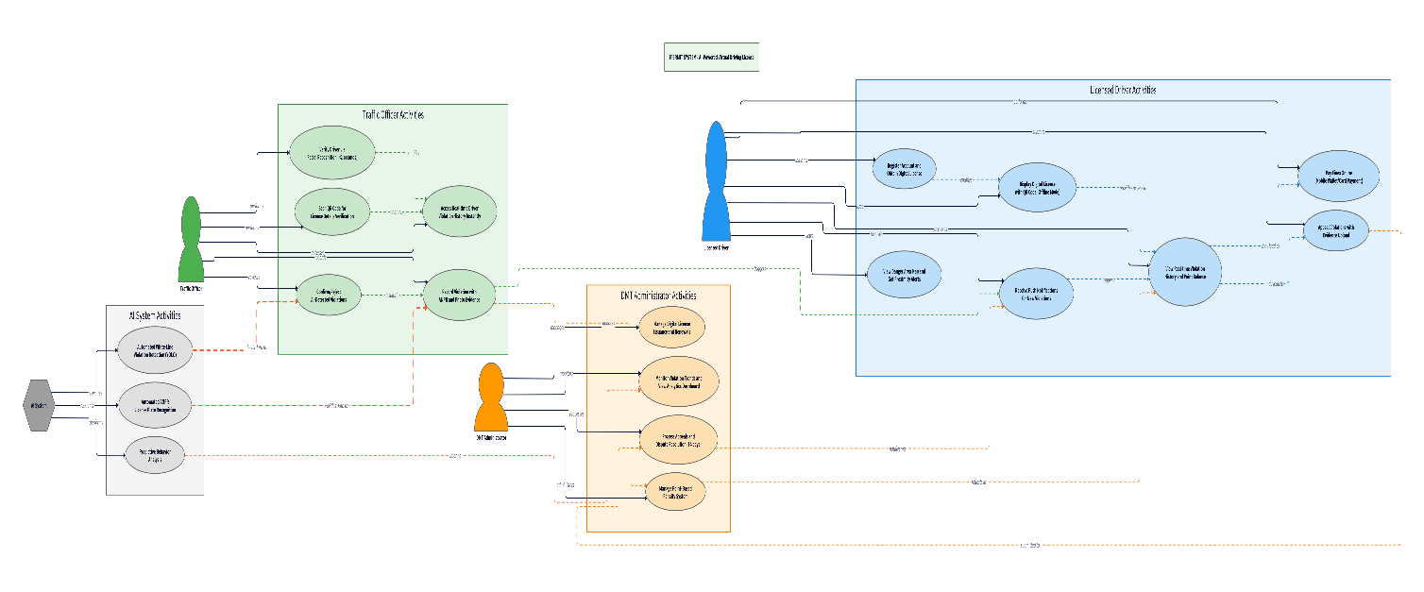
Key Improvements: Digital license instant mobile display, <2 second facial recognition vs. 4+ minute manual checks, automated violation detection, real-time notifications vs. delayed paper notices, transparent point system with real-time visibility, convenient online payments vs. office visits, unified databases vs. fragmented silos, predictive analytics identifying high-risk drivers, evidence-based appeals vs. paper disputes, proactive danger zone alerts preventing accidents.

3.4 Feasibility Study
- Technical Feasibility: AI technologies mature with facial recognition achieving >95% accuracy, ANPR 94-96%, violation detection 89-92%. Open-source frameworks (TensorFlow, YOLO v5, FaceNet) accessible. Flutter enables cross-platform mobile development, Firebase/Supabase provide scalable backends. Sri Lanka's 150%+ mobile penetration supports deployment. Conclusion: Technically feasible with manageable risks in model localization.

- Economic Feasibility: Development costs minimal for academic project: open-source software, hardware ($3,000-5,000), cloud ($200-500/month pilot), dataset creation ($2,000-3,000). Automation reduces verification time (5 minutes to 30 seconds), eliminates physical license production, improves detection. World Bank suggests ROI within 3-5 years. Conclusion: Economically feasible for pilots; scaled deployment requires government funding but promises long-term savings.

- Operational Feasibility: Stakeholders include 4.5M drivers, 8,000 officers, DMT administrators. Surveys show 72% driver willingness, 68% officer support, with concerns on privacy (64%), reliability (58%), bias (43%). Conclusion: Operationally feasible with stakeholder engagement, training, phased rollout, transparent governance.

- Legal Feasibility: Motor Traffic Act requires physical licenses; digital transformation policies provide general support but specific regulations absent. Required amendments: digital license recognition, digital evidence admissibility, biometric governance. Conclusion: Legal barriers require legislative action but navigable through phased implementation.

3.5 Functional Requirements
- Digital License Management - Issue digital licenses, support offline access for 7 days, enable online renewals. Justification: Addresses core requirement for digital transition with offline capability for poor connectivity areas.

- Facial Recognition - Capture images, match with >95% accuracy, complete within 2 seconds, liveness detection. Justification: Eliminates forged licenses while providing rapid verification meeting officer workflow needs.

- ANPR - Detect plates >90% accuracy handling Sri Lankan formats, link to records, capture evidence. Justification: Enables automated vehicle identification supporting violation detection.

- Violation Detection - Detect white-line violations >85% accuracy, record with timestamp/GPS/photo, require officer confirmation, notify drivers within 24 hours. Justification: Automates detection previously impossible manually while maintaining human oversight.

- Point System - Assign points 1-10 by severity, maintain cumulative balances, trigger suspension at 12 points, provide real-time driver visibility. Justification: Implements transparent accountability (81% driver support in surveys).

3.6 Non-Functional Requirements
Performance: 10,000 concurrent users; facial recognition <2 sec; ANPR <1 sec; 99.5% peak uptime. Security: AES-256 encryption; HTTPS; role-based access; audit logging; irreversible biometric hashes. Usability: <5 min training; multilingual (Sinhala/Tamil/English); WCAG 2.1 AA accessibility; <3 clicks to common functions. Reliability: 99.9% availability; automatic failover; offline license mode; 6-hour backups. Privacy: Data minimization; purpose limitation; 90-day biometric retention; GDPR-aligned controls addressing 64% privacy concerns.

3.7 Methodology
Agile Development with Scrum selected for: iterative AI model development, frequent stakeholder feedback, flexibility for technical challenges, risk mitigation through incremental delivery, continuous testing. Structure: 2-week sprints over 12 months. Phases: Sprint 1-2 (infrastructure), 3-5 (facial recognition with localized dataset collection), 6-8 (ANPR/violation detection), 9-10 (points/payments), 11-12 (testing/refinement with officer and driver participants). Regular sprint reviews with DMT and officers ensure user-centered development.

CHAPTER 4: DESIGN
4.1 Introduction
This chapter presents the design of the integrated AI-Based Virtual Driving License System, hereafter referred to as iPermit. The system combines a digital license management platform, facial recognition based driver identification, and AI-supported traffic violation monitoring into a unified architecture. The purpose of this chapter is twofold: (1) to evaluate competing design strategies and justify the chosen system architecture, and (2) to describe the detailed system design using appropriate diagrams and models.
The chapter begins by comparing alternative design strategies, followed by the selected architecture based on scalability, interoperability, and suitability for AI integration. Subsequently, the system’s functional and structural design is presented using UML and data modelling diagrams, including use case diagrams, class diagrams, sequence diagrams, activity diagrams, interface design, and database schema.
4.2 System Design Process
Evaluation of Alternate Solutions
Several design strategies were analyzed before selecting the final architecture:
Alternative 1: Monolithic Web Application
- Single deployment unit containing UI, backend logic, database operations, and AI models.
- Advantages: Simple deployment, low initial cost.
- Disadvantages: Poor scalability, high coupling, unsuitable for real-time FR and AI processing workloads.
Alternative 2: Standalone Modules (Non-integrated)
- Digital license system and FR prototype operate independently.
- Advantages: Easy development.
- Disadvantages: No real-time data sharing, unsuitable for production, fails research aim of “integrated AI-based system”.
Alternative 3: Microservices-Based Future Architecture (Selected)
- Core services operate independently:
  - Frontend Service (React)
  - Authentication Service
  - License & Violation Management Service
  - Facial Recognition Microservice
  - AI Violation Detection Microservice (YOLO/Computer Vision)
  - Notifications Service
  - Database Service (MongoDB)
- Advantages: Scalability, loose coupling, easier future upgrades, real-time processing, API gateway for unified communication.
- Justification: Aligns with long-term national-scale deployment, supports advanced AI workloads, compatible with mobile and web.
Thus, Option C - Future Integrated Microservices Architecture was selected as the basis of system design.

4.2.1 Use Case Diagrams
Use Case Diagram of the iPermit system. It identifies the main actors, including the Driver, Traffic Police Officer, Administrator, and the external AI microservices. The diagram shows how these actors interact with system functions such as license viewing, identity verification, fine issuing, and violation detection. This model provides a high-level understanding of the system’s functional requirements and user interactions.
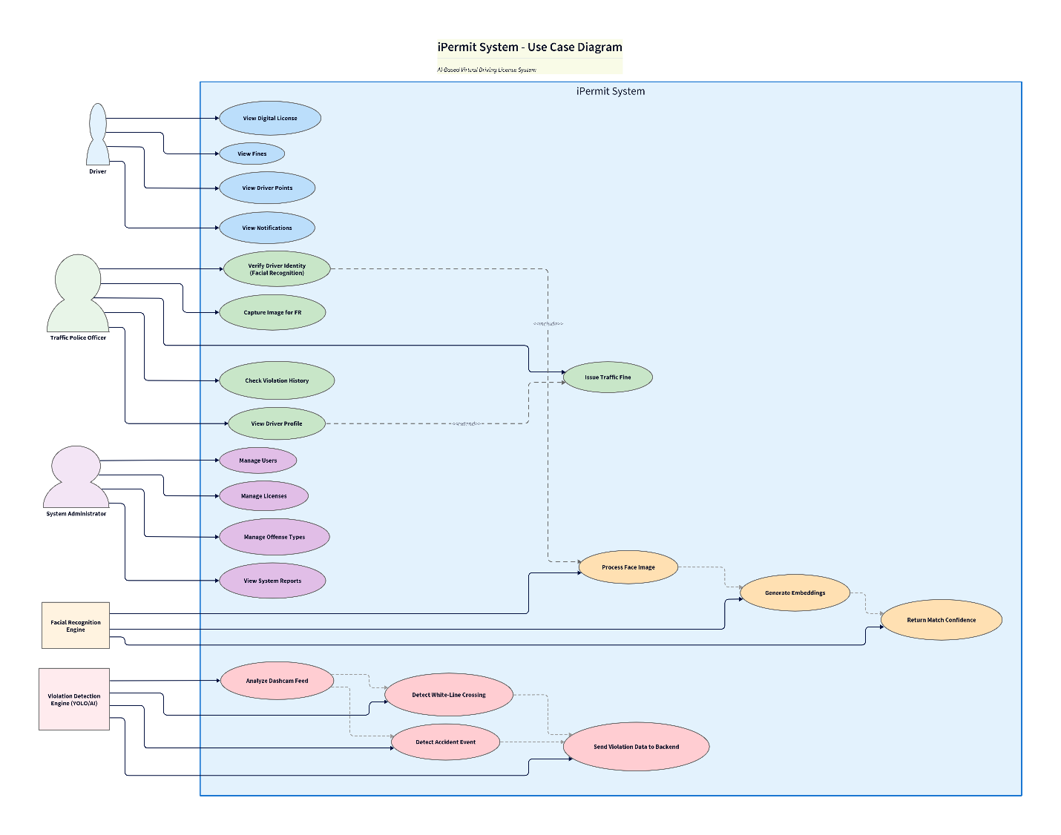

4.2.2 Class Diagrams
Class Diagram representing the structural design of the iPermit system. It outlines the main classes such as Driver, License, Fine, Violation, and the AI-related components. The relationships between these classes demonstrate how data is organized and how system components communicate. This diagram forms the foundation for database design and backend implementation decisions.
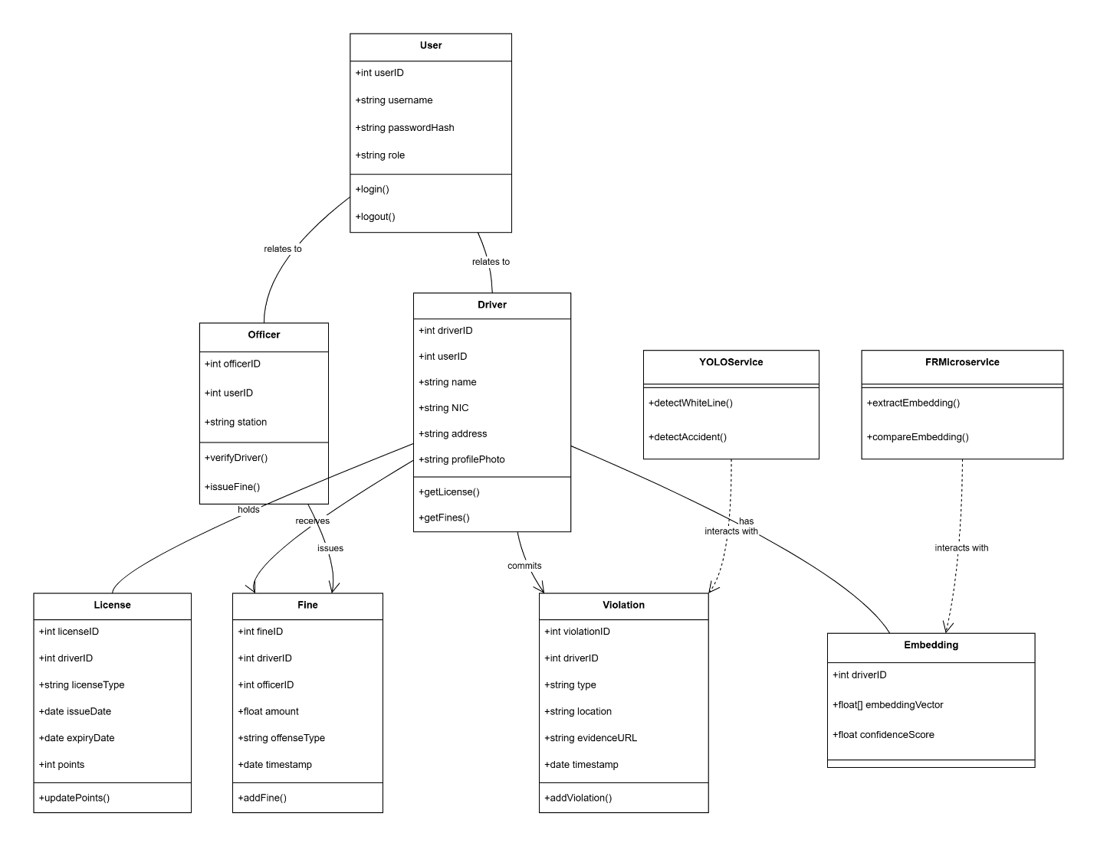

4.2.3 Sequence Diagrams
Sequence Diagram for the facial recognition-based driver verification process. It describes the chronological interaction between the officer, frontend interface, API gateway, facial recognition microservice, AI model, and database. This diagram clarifies the real-time workflow of image capture, embedding generation, identity matching, and result delivery.
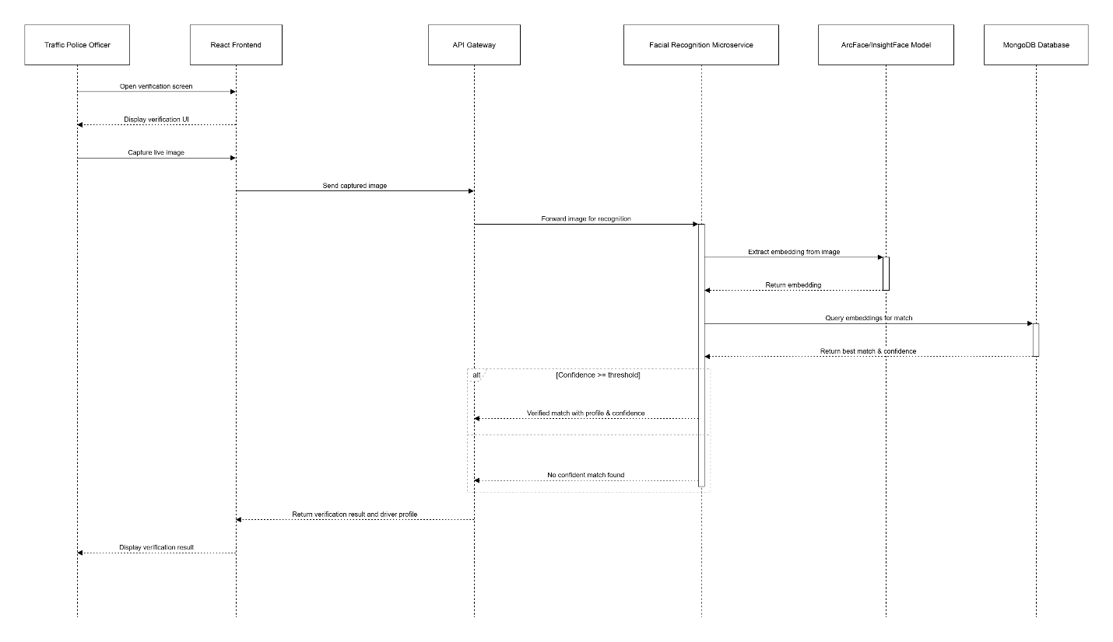

4.2.4 Activity Diagrams
Driver Verification
Activity Diagram for the driver verification workflow implemented in the iPermit system. The diagram presents the flow of activities from capturing the driver’s image to embedding extraction and identity confirmation using AI processing. Decision points such as confidence threshold checks are highlighted to demonstrate the verification logic.
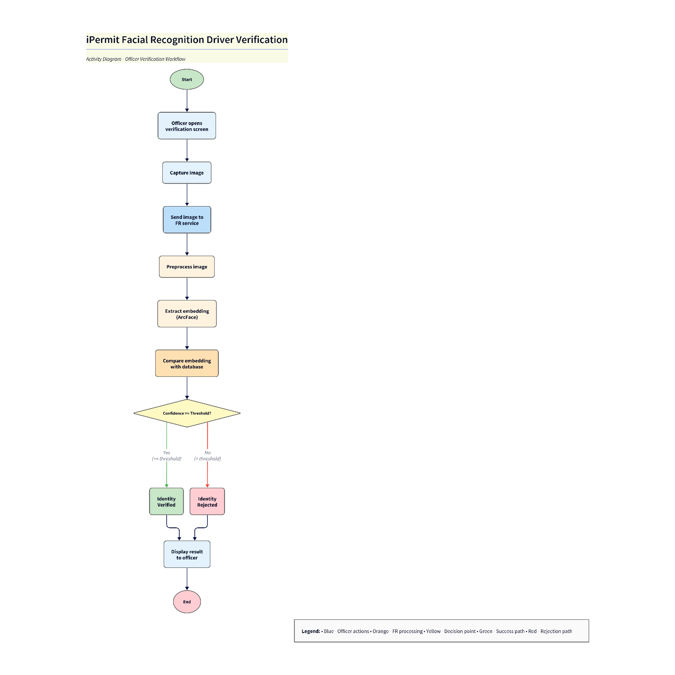
Fine Issuing
Activity Diagram for the process of issuing traffic fines. It describes the steps followed by a police officer, from driver identification to offense selection and record submission. The diagram emphasizes how system automation supports point deduction, fine calculation, and driver notification.
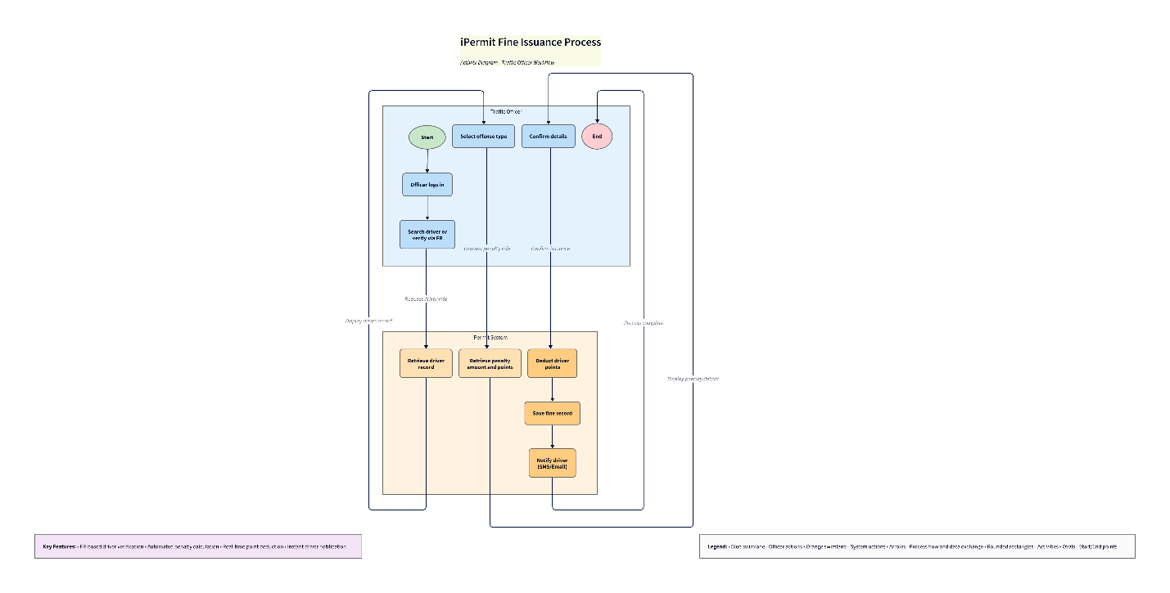

4.3 Interface Design
4.3.1 Design Principles
The UI follows:
- Consistency: Tailwind utility classes used globally.
- Accessibility: High-contrast colors and responsive layouts.
- Minimal Cognitive Load: Simple navigation for officers.
- Device Responsiveness: Validated on desktop/tablet/mobile.
- Error Prevention: Input validation, confirmation dialogs

4.3.2 Actual Screens of the System
- Driver Dashboard:
Displays digital license card, points remaining, fines summary.
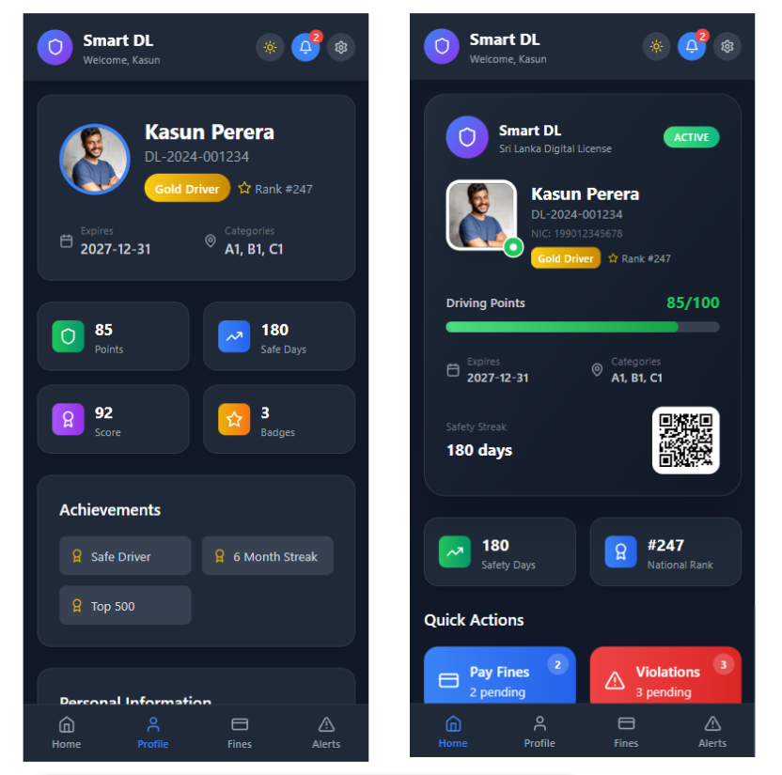

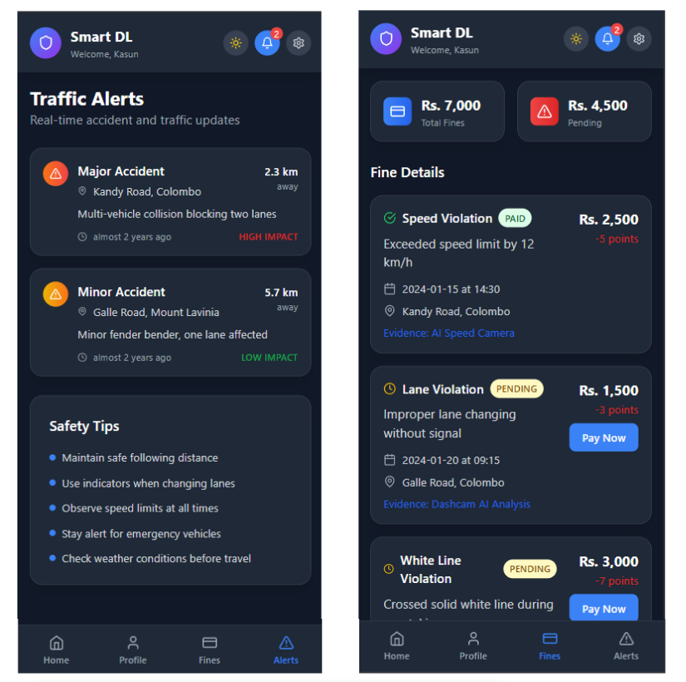

- Officer Dashboard:
Quick-scan face verification, fine issuing panel, violation viewer.

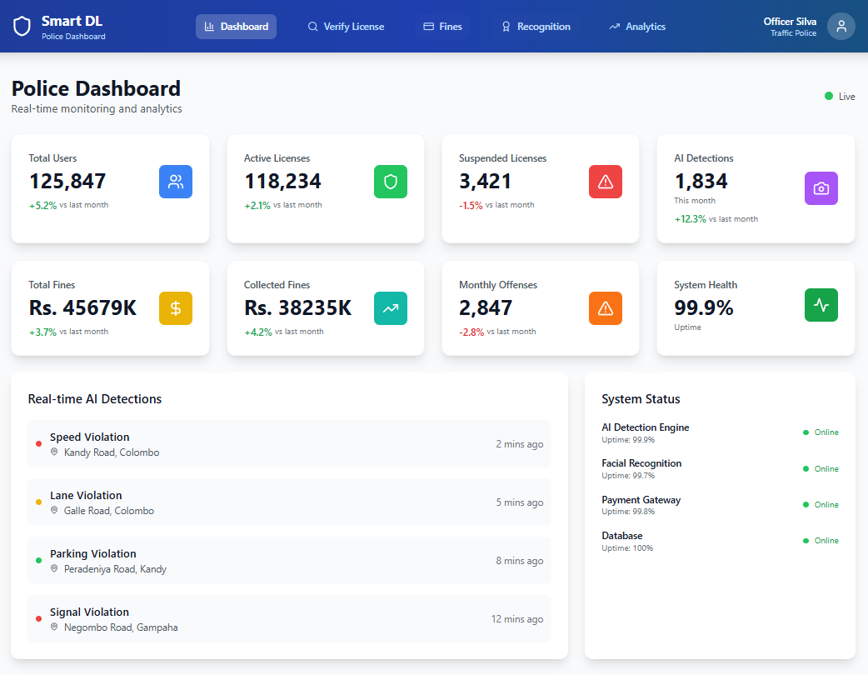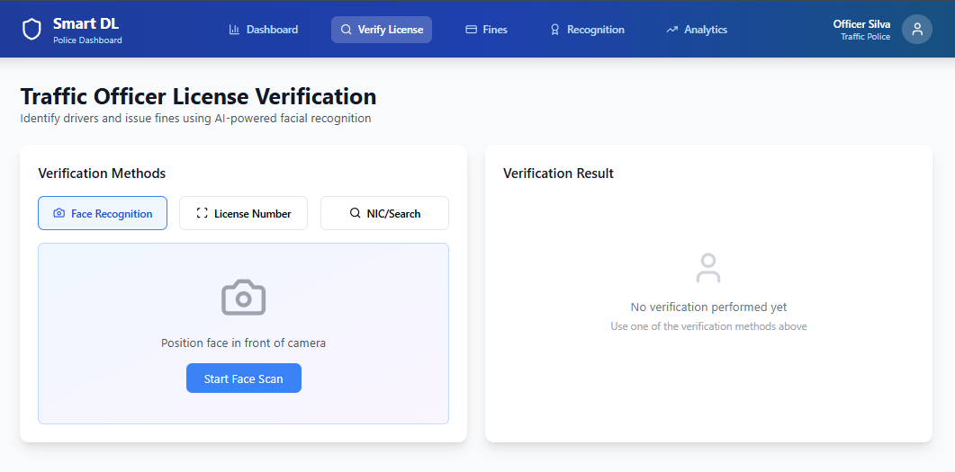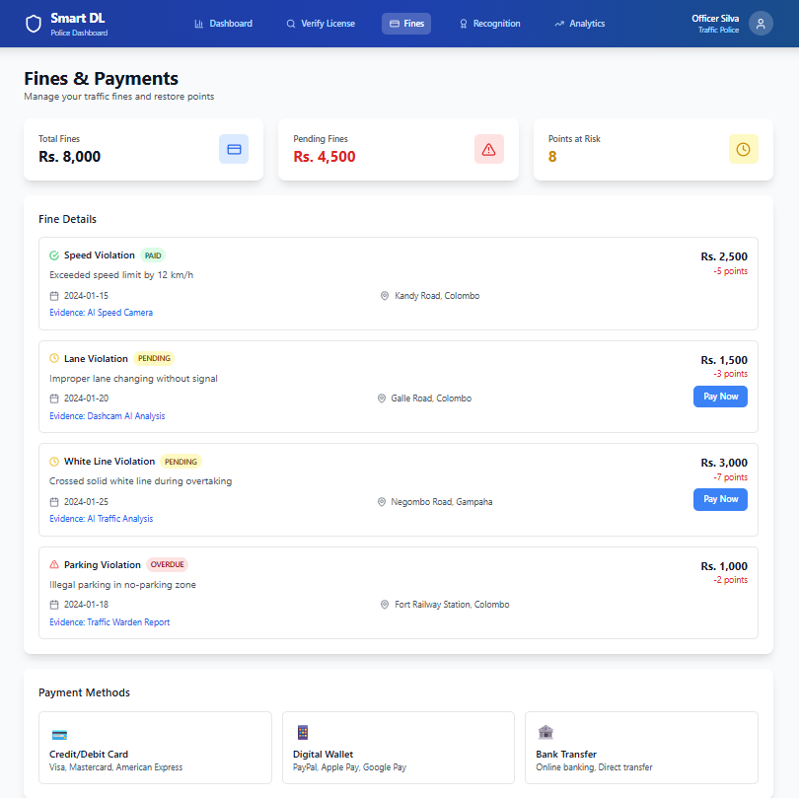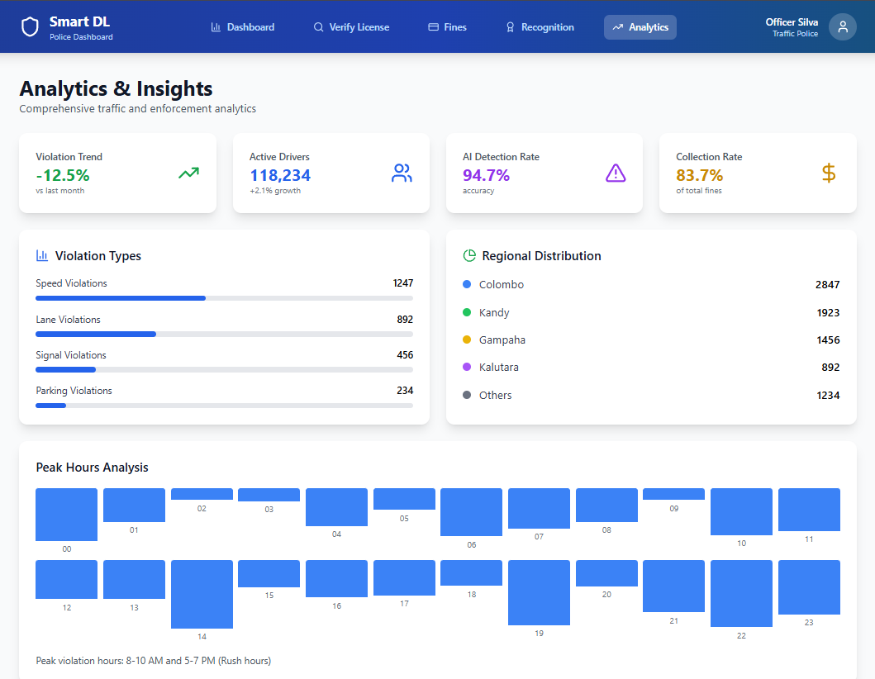

- Admin Dashboard:
System statistics, user management, violation reporting.

4.4 Database Design
4.4.1 Entity Relationship Diagrams (ERD)
Entity Relationship Diagram representing the database structure of the iPermit system. It includes key entities such as User, Driver, License, Fine, Violation, and Embedding, along with their relationships. This diagram supports the logical design of the database and ensures normalization and consistent data flow between system components.
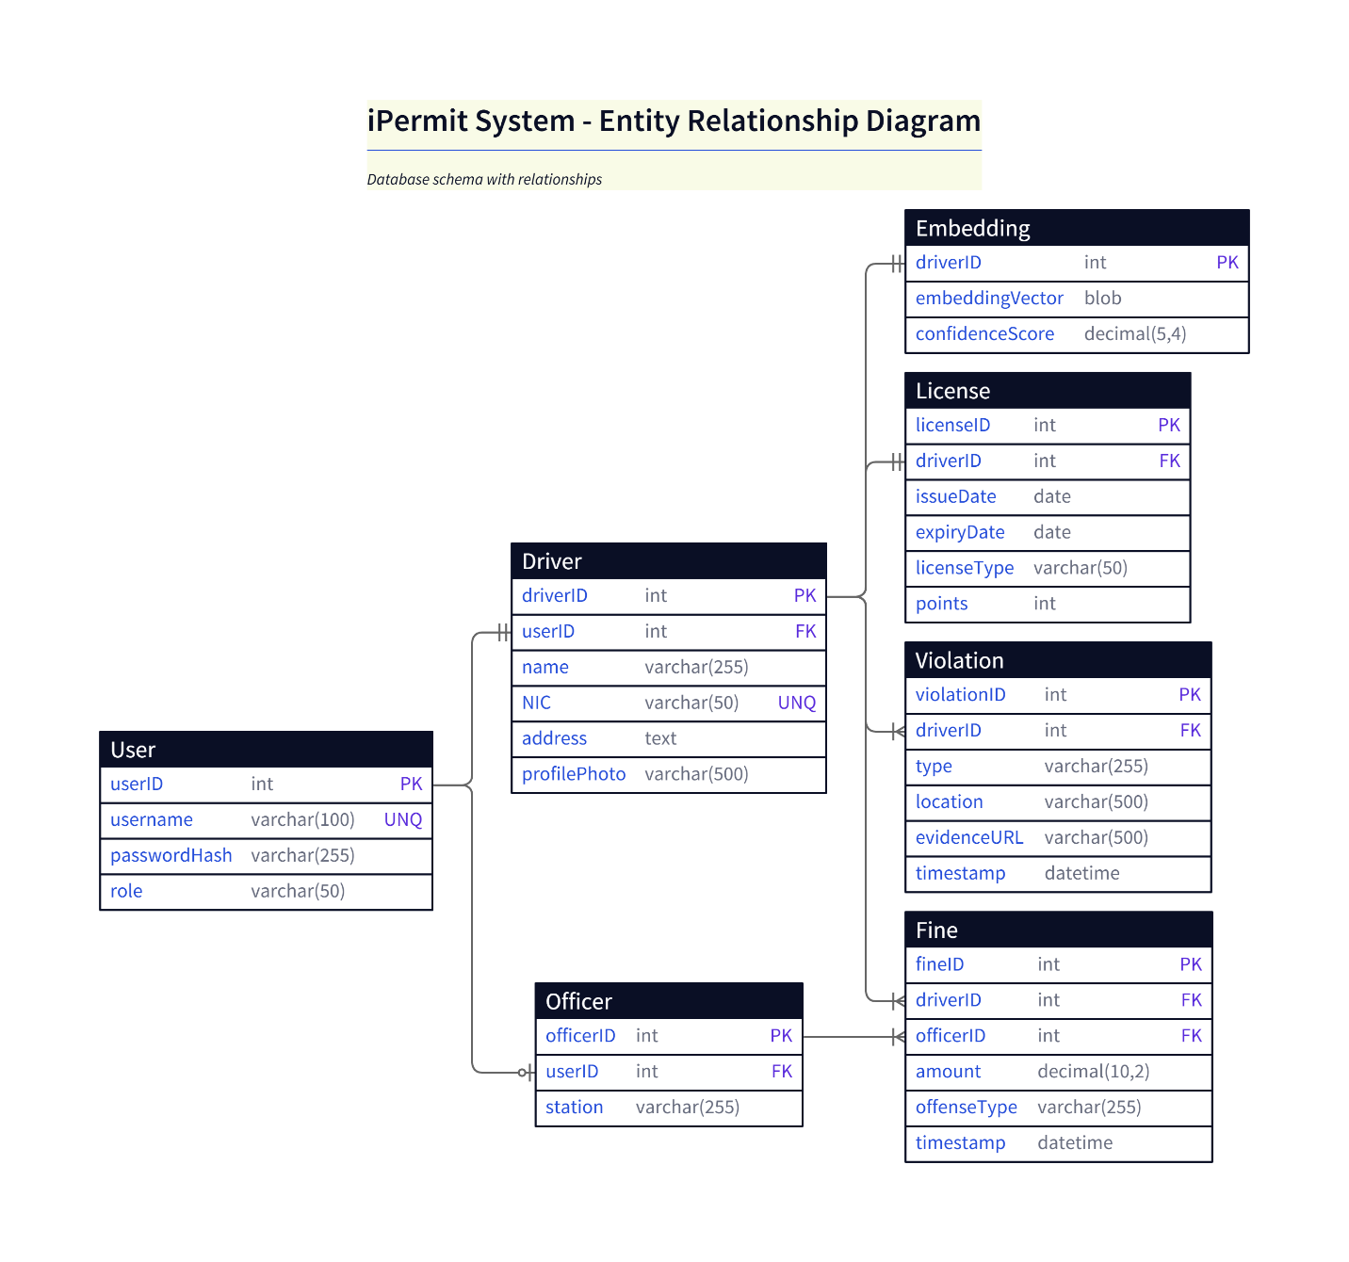

4.4.2 Normalization
NF
- All tables have atomic fields.
- No repeating groups.
2NF
- All non-key attributes depend on full primary key.
- Composite keys resolved (e.g., violation tables split).
3NF
- No transitive dependencies.
- User credentials separated into User table.

4.4.3 Relational Schema
User(userID PK, username, passwordHash, role)
Driver(driverID PK, userID FK, name, NIC, profilePhoto)
License(licenseID PK, driverID FK, issueDate, expiryDate, class, points)
Fine(fineID PK, driverID FK, officerID FK, offense, amount, timestamp)
Violation(violationID PK, driverID FK, type, location, evidenceURL, timestamp)
Embedding(driverID PK, embeddingVector)
Officer(officerID PK, userID FK, station)

4.5 Hardware Component (if any)
primarily software-based, the system uses:
Hardware Requirements
- Smartphone (for FR data capture)
12MP camera, minimum 30fps video for violation detection.
- Server/Cloud Infrastructure
For hosting microservices and AI computation.
- Desktop/Laptop Device
For officer dashboard usage during operations.
If extended to real deployment:
- CCTV camera feeds for white-line and accident monitoring.
- GPU servers (NVIDIA RTX series) for model inference.

